**DAILY ONLINE ACTIVITIES SUMMARY**

|  |  |  |  |  |  |  |  |
| --- | --- | --- | --- | --- | --- | --- | --- |
| **Date:** | **13/06/20** | | | | **Name:** | **Bhuvana S** | |
| **Sem & Sec** | **8th sem A sec** | | | | **USN:** | **4AL16CS022** | |
| **Online Test Summary** | | | | | | | |
| **Subject** | | **IOT** | | | | | |
| **Max. Marks** | | **30** | | **Score** | | **30** | |
| **Certification Course Summary** | | | | | | | |
| **Course** | **Webinar on skill development** | | | | | | |
| **Certificate Provider** | | | **Brainovision** | **Duration** | | | **2hr** |
| **Coding Challenges** | | | | | | | |
| **Problem Statement: Write a C program to calculate electricity bill** | | | | | | | |
| **Status: Completed** | | | | | | | |
| **Uploaded the report in Github** | | | | **Yes** | | | |
| **If yes Repository name** | | | | **bhuvanashivakumar** | | | |
| **Uploaded the report in slack** | | | | **Yes** | | | |

Certification Course Details:

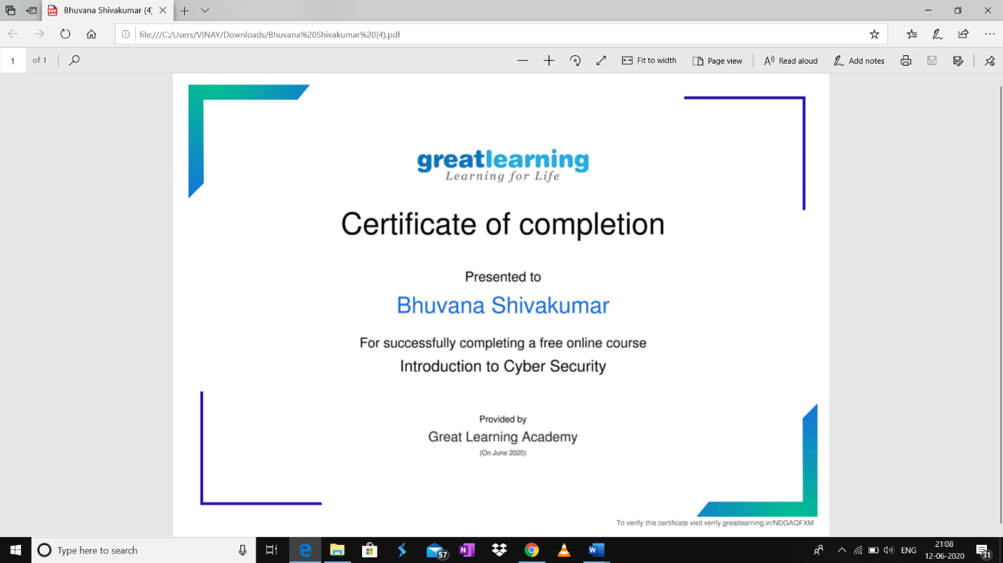

Coding Challenges Details:

//Write a C Program to calculate Electricity Bill

#include <stdio.h>

int main()

{

int unit;

float amt, total_amt;

printf("Enter total units consumed: ");

scanf("%d", &unit);

if(unit <= 100)

{

amt = unit * 10;

}

else if(unit <= 200)

{

amt = 1000 + ((unit-100) * 15);

}

else if(unit <= 300)

{

amt = 2500 + ((unit-200) * 20);

}

else

{

amt = 4500 + ((unit-300) * 25);

}

total_amt = amt;

printf("Electricity Bill = Rs. %d", total_amt);

return 0;

}